**Shri Vaishnav Vidyapeeth Vishwavidyalaya, Indore**

**Shri Vaishnav Institute of Information Technology**

**Department of computer science and engineering**



**PROJECT**

**B. Tech + MBA(CSE)**

**Subject:Advanced Java Programming**

**Enrollment no.:1810DMBCSE03309**

**Course Code: BTCS-409**

**2ndYear /4th semester**

**Submitted by Subject Teacher**

**Raj Gupta Mr. Sachin Chirgaiya**

**Objective/ Vision:**

The main objective of the Java Project is to develop web application that manages the “Fee System “ of any institute. The Accountant can generate fee receipt on payment of fee

**Users of the System:**

1. Accountant

**Functional Requirements:**

* The user can register before login to the software
* The user Candidates can login
* The user can generate Fee Recipt of the students and can logout there id

**Tools to be used:**

1. Used NetBeans for coding
2. SQLyog IDE for MySQL database.
3. Apache Tomcate for the server

**Front End and Back End:**

1. Front End: JSP,Javascript,AJAX,JDBC
2. Back End: MYSQL

**Database:**

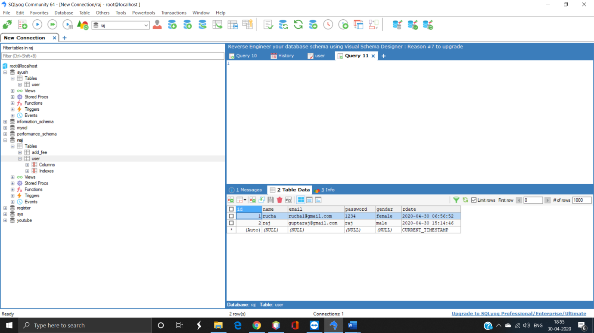

**How project works?**

To get detail explanation about project, it includes snapshots with explanation.

**Screenshots of output:**

Login Page->

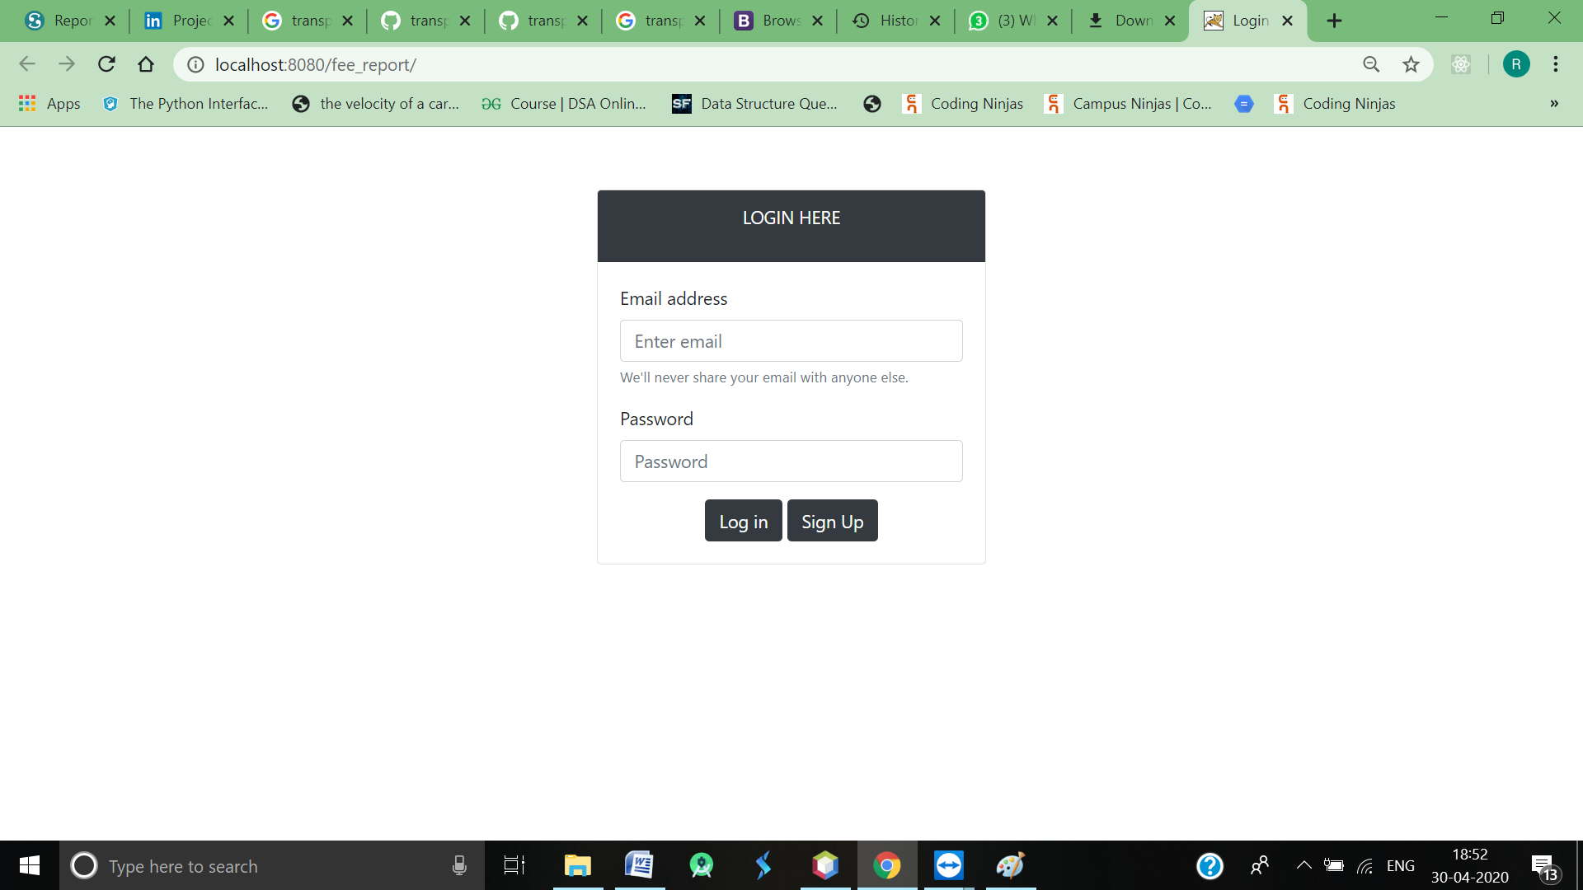

* User can login if already have an account or create using sinp up page

Sign up Page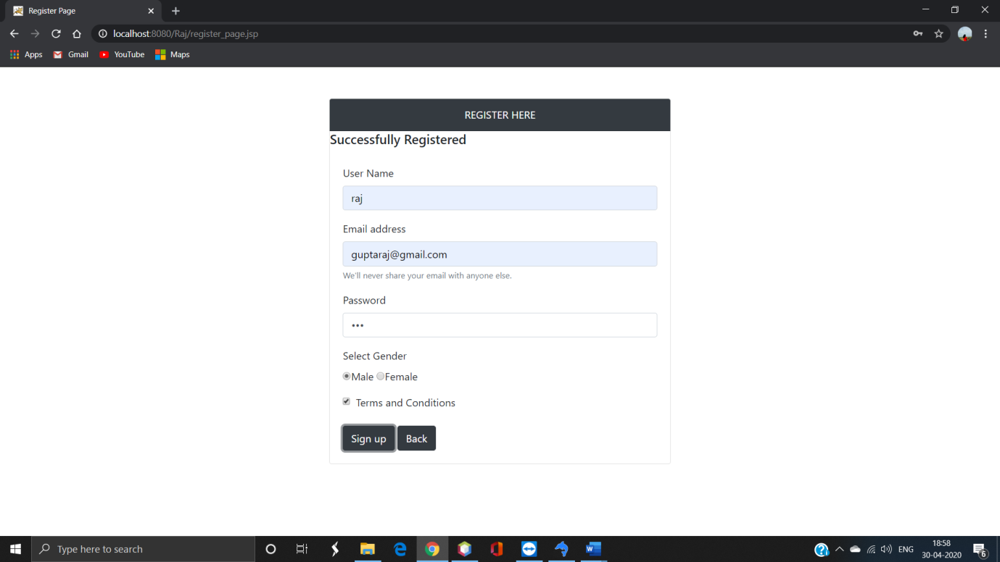->

* After login user can go to home page
* Login verification is done using database

Home Page->

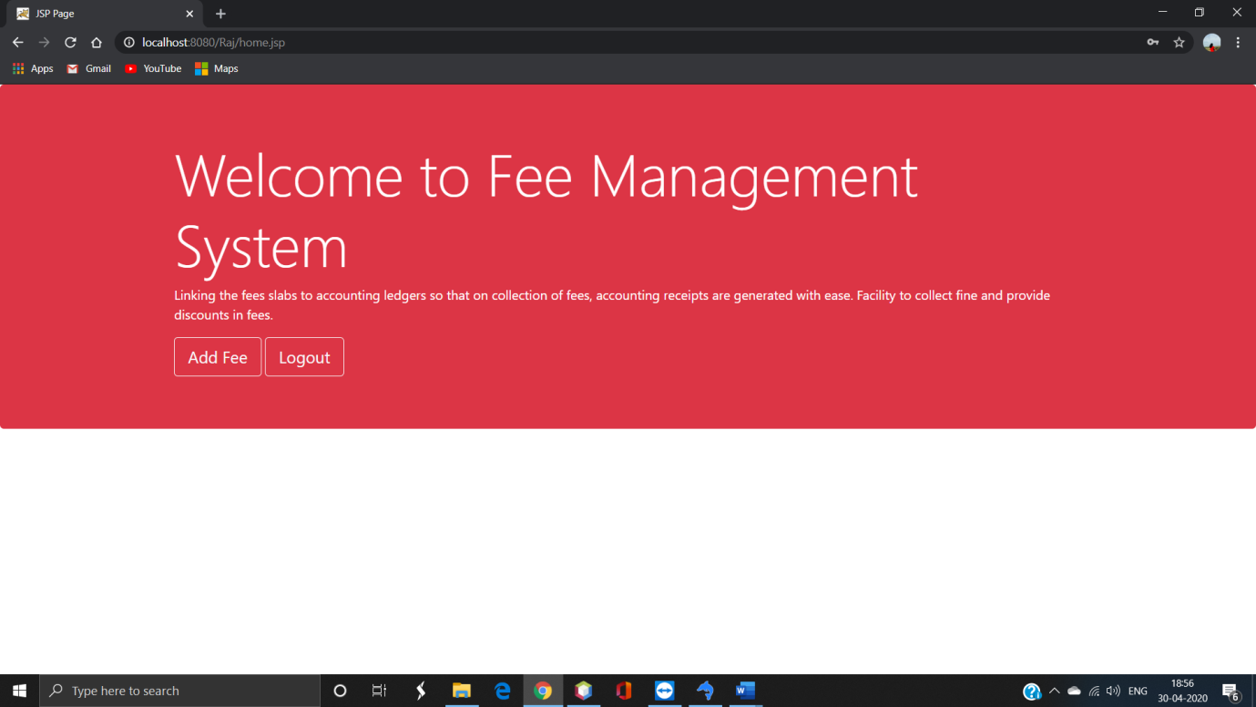

* User can add fee for student and generate receipt

Add fee page->

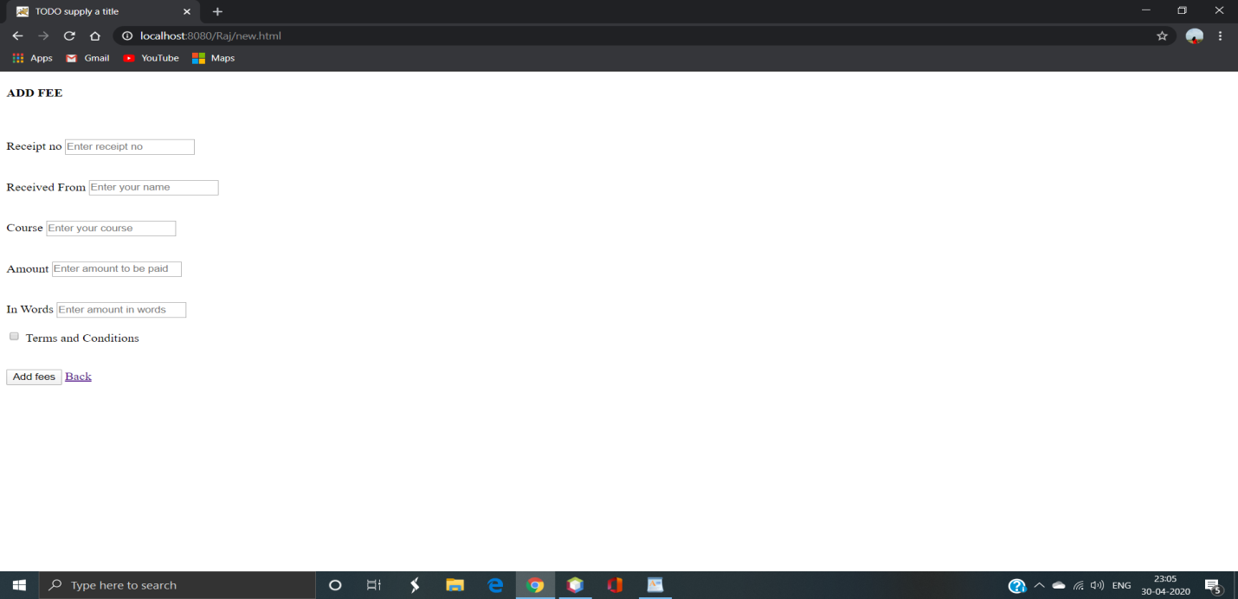

Generate receipt->

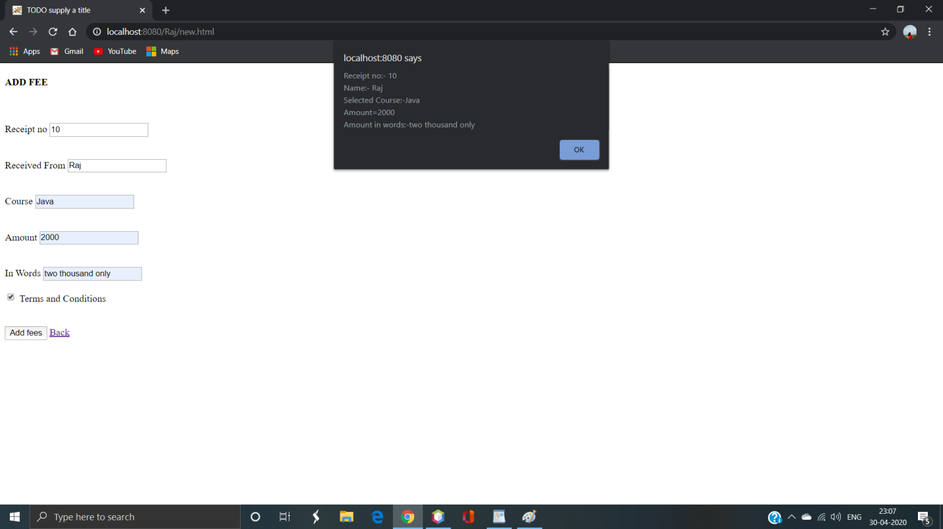

* User can logout and go back to login page

Login Page->

